## DiscountMate Gmail Account Details

**Email:** discountmate.databytes@gmail.com

**Password:** discountmatedatabytes1@

Note: MongoDb is accessed by first logging into this account in gmail. There is a security setup by gmail that is causing issues. A notification is sent via the gmail app to a mobile account that is already logged in to the DiscountMate Gmail Account. So new users are having to ask existing users to help them login by approving the notification.

## How to run the Web Application

1. Clone the repository to your device. URL of repository: <https://github.com/DataBytes-Organisation/DiscountMate_new>
2. Open the folder by using Visual Studio Code.
3. Open two terminals. In one navigate to the Frontend folder.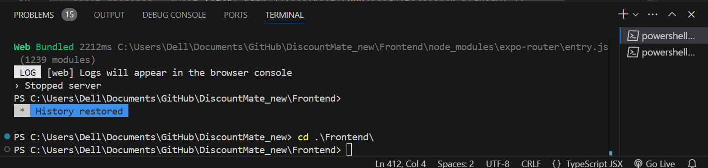

And in the other navigate to the Backend folder

1. Run the Backend folder first, by using the command **node index.js**

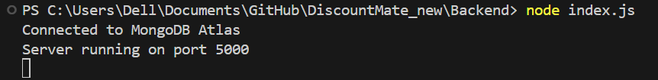

1. Then open the Frontend folder type **npm I** to install all the necessary packages.
2. Then run the Frontend folder by using the command **npx expo start**

Note: This may take 5 min and more things might download.

1. You can click on <http://localhost:8081> to access the website